DBT ASSIGNMENT -4

1) Write a select command that produces the order number, amount, and date for all rows in the Orders table?
Ans--
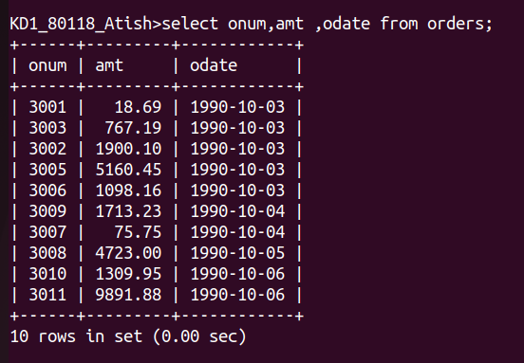

2)Write a query that produces all rows from the customers table for which the salespersons number is 1001.
Ans--
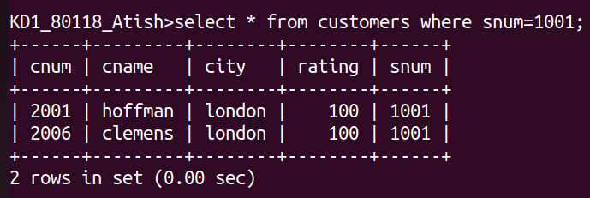

3) Write a query that displays the salespeople table with the columns in the following orders: city, sname, snum, comm.
Ans--
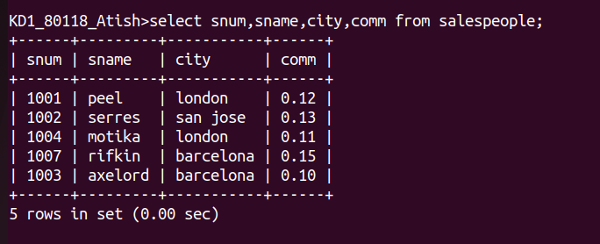

4) write a select command that produces the rating followed by the name of each customer in San Jose.
Ans--
